

**Airbnb price analysis 2016**

**By Myles Trowell**

**October 21, 2024**

**Case Study**

Our client is starting an Airbnb business in the Seattle area and aims to identify the optimal location to purchase a home that they can also live in part-time. The goal is to maximize rental income while considering key factors that influence profitability, such as location, home features (e.g., number of bedrooms), and rental demand trends.

**Link to tableau dashboard:** <https://public.tableau.com/app/profile/myles.trowell/viz/Airbnbfullproject_17295428547250/Dashboard1>

**Business Objective**

The client seeks to maximize profit from renting out their home on Airbnb by making data-driven decisions regarding location, pricing, and competition. In particular, they want to understand:

1. **Location Profitability**: Identifying the most lucrative zip codes in terms of rental income, based on home price, average Airbnb rates, and demand.
2. **Optimal Rental Timing**: Understanding when Airbnb rentals generate the highest income to strategically rent out the property during peak times and live there during off-peak seasons.
3. **Key Factors Affecting Airbnb Price**: Evaluating how home features—specifically the number of bedrooms—affect Airbnb prices to ensure that the property is both competitive and profitable.
4. **Competition Analysis**: Assessing the competition within specific zip codes, particularly focusing on homes with a similar number of bedrooms to gauge market saturation and adjust pricing strategies.

**Data Insights**

1. **Zip Code Analysis**: The client needs a visual map showing average home prices and rental income by zip code, taking into account latitude and longitude to identify desirable neighborhoods.
2. **Seasonality and Demand**: The client requires a timeline of when Airbnb guests are spending the most, to target periods of high demand for rentals.
3. **Impact of Bedrooms on Pricing**: By comparing the number of bedrooms in Airbnb listings with their rental prices, the client can determine the optimal house size to maximize revenue.
4. **Competitive Landscape**: Understanding how many Airbnb listings with similar bedroom counts exist within target zip codes will help the client evaluate competition and set strategic pricing.

**This case will allow the client to make informed decisions about where to buy, when to rent, and how to position their Airbnb to stand out in a competitive market, ensuring optimal rental income.**

**Zip Code Analysis**

The highest average daily rental rate is found in **zip code 98134**, where properties command an average of **$206 per day**. This area represents a prime location for higher-end Airbnb rentals, making it a potentially lucrative option for our client that is seeking to maximize his income. And in contrast, **zip code 98125** is the least expensive, with an average daily rental price of **$65 per day**. While this area may offer more affordable properties, the lower rental income potential could impact overall profitability for our client.

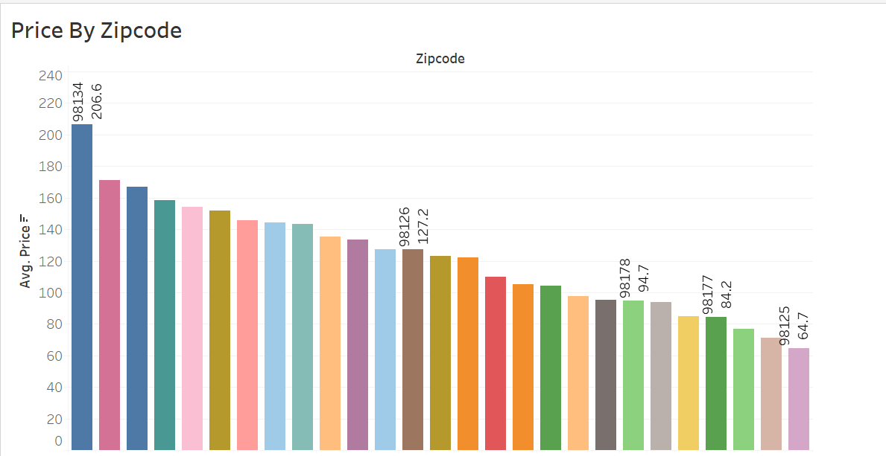

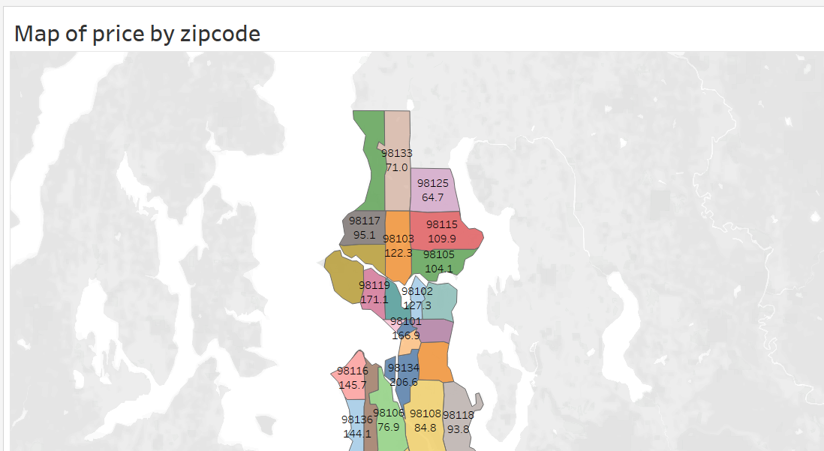

**Seasonality and demand**

In addition to maximizing rental income, our client also wishes to live in the property part-time. To achieve this, it was important to understand the best times of the year to list the home on Airbnb as it was critical for profit margins. During the summer months, Airbnb rentals in the Seattle area experience a significant surge in demand, resulting in total rental revenues peaking at **$2 million**. This makes summer an ideal period to list the property, as the high demand will likely yield maximum occupancy and income. However, by the end of the year, rental activity also sees a notable increase, with **average sales reaching $2.1 million**. This indicates that the holiday season and year-end festivities drive strong demand, providing another lucrative window for listing the property. By focusing on these two peak periods—summer and year-end—the client can strategically rent out the home when demand is at its highest, ensuring optimal profitability while balancing personal use of the property during less active periods.

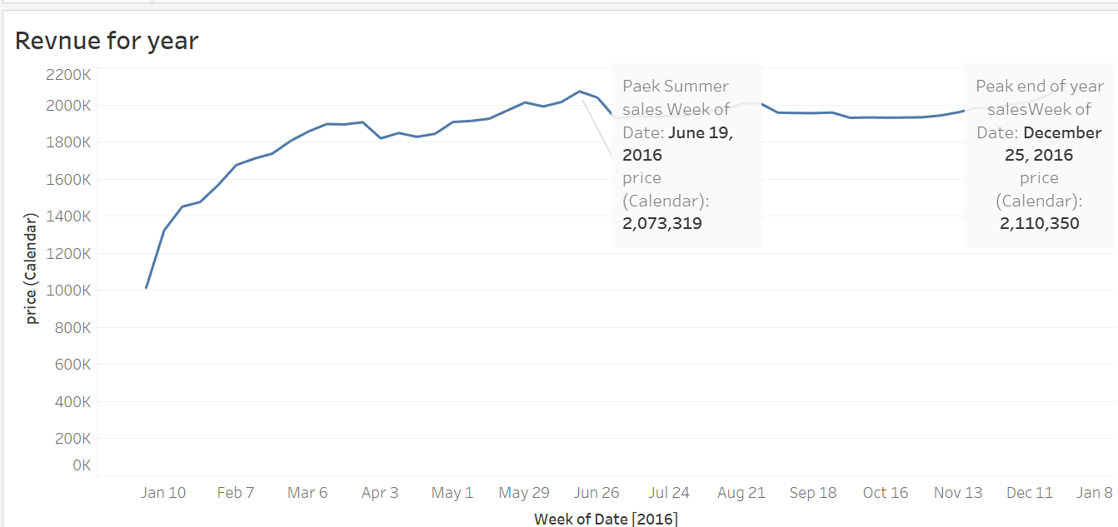

**Impact of bedrooms on pricing**

One of the primary factors influencing Airbnb rental rates is the size of the property, specifically the number of bedrooms. Typically, larger properties with more bedrooms command higher nightly rates, offering increased revenue potential for hosts.

**Our analysis shows the following pricing trends in the Seattle area:**

* **1-Bedroom Property**: The average nightly rate for a 1-bedroom Airbnb is **$96**.
* **6-Bedroom Property**: In comparison, a 6-bedroom property rents for an average of **$584 per night**.

This substantial increase in pricing based on the number of bedrooms suggests that properties with more bedrooms provide an opportunity for significantly higher rental income. For our client, investing in a larger home with multiple bedrooms could lead to higher profitability, as it enables them to charge more per night while catering to larger groups or families who may be willing to pay premium prices for additional space.By selecting a property with a greater number of bedrooms, the client can capitalize on this trend to maximize potential earnings from their Airbnb listing.

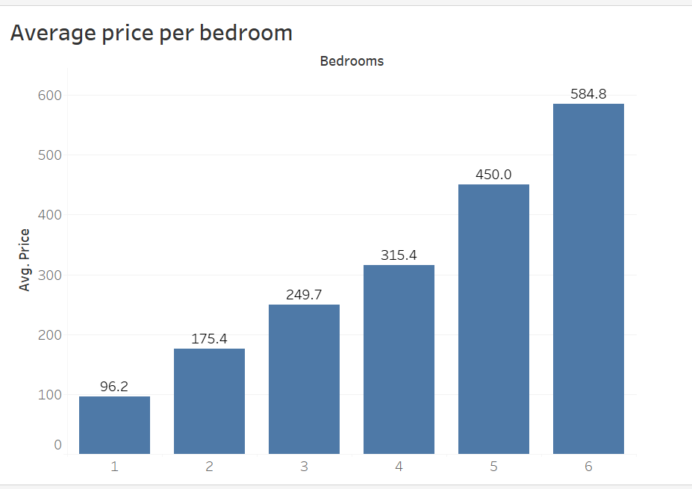

**Competitive landscape:**

A detailed analysis of the Airbnb market in the Seattle area reveals an important trend regarding competition based on the number of bedrooms in rental properties. As the number of bedrooms increases, the level of competition decreases, providing potential opportunities for property differentiation and higher pricing.

* **1-Bedroom Properties**: There is a high level of competition, with **1,800 homes** listed as 1-bedroom properties.
* **2-Bedroom Properties**: Competition begins to drop, with **480 homes** offering 2 bedrooms.
* **3-Bedroom Properties**: The number of listings decreases further to **206 homes** with 3 bedrooms.
* **4-Bedroom Properties**: There are only **55 homes** available with 4 bedrooms.
* **5-Bedroom Properties**: The market becomes more exclusive, with just **20 homes** offering 5 bedrooms.
* **6-Bedroom Properties**: At the top end, competition is extremely low, with only **5 homes** offering 6 bedrooms.

This data indicates that as the number of bedrooms increases, there is significantly less competition in the Airbnb market. For our client, investing in a larger property with more bedrooms not only allows for higher pricing potential but also reduces the likelihood of competing directly with many similar listings. This scarcity of larger properties provides a competitive advantage, enabling the client to capture demand from larger groups or families willing to pay a premium for more spacious accommodations.

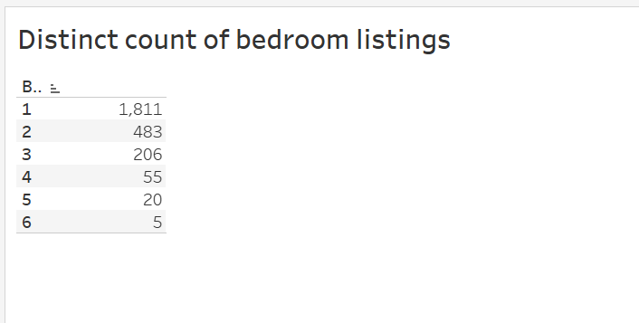

**Conclusion**

In summary, the Seattle Airbnb market presents significant opportunities for our clients to maximize rental income by strategically selecting property size and timing their rental periods. Zip code 98134 offers the highest potential for profitability, with average daily rates of $206, while areas like 98125 present more affordable but less lucrative options. The analysis highlights that the summer and year-end periods are ideal for listing the property due to peak demand, providing the best opportunity to generate substantial rental income.

Investing in larger properties with more bedrooms proves to be a valuable strategy, as higher bedroom counts command significantly higher nightly rates, with 6-bedroom properties averaging $584 per night. Furthermore, competition decreases as the number of bedrooms increases, offering our client a competitive advantage in a less saturated segment of the market. By focusing on these factors, our client can maximize rental income while balancing personal use of the property, ensuring long-term profitability in their Airbnb venture.